Sensitivity Analysis

**Incentive Mechanisms for Mobile Crowdsourcing, Reaching Spatial and Temporal Coverage Under Budget Constraints**

This report will cover the sensitivity analysis of the model proposed by Dr. Luis Jaimes, and his research team at Florida Polytechnic University. See [National Science Foundation](https://nsf.gov/awardsearch/showAward?AWD_ID=1739409&HistoricalAwards=false) for more information.

The mathematical model goes as such:

$$Let G be the grid generated by the NxM matrix$$

$$Let C be the set of cars, and J be the set of crowdsources, for every car c in C at position \left(x, y\right) in$$

$G calculate t_{c}^{j}=\frac{(w_{j}-1)R_{j}}{w_{j}k_{j}}$ which is the Time Sensing Plan (AKA How much data/time the car plans to spend in this cell). R is the reward designated by crowdsourcer J at cell (X,Y), w is the number of participants in all neighboring cells, and k is the cost of data collection at cell (X,Y).

For every adjacent cell to cell (X,Y) calculate the expected utility using the formula $E\left(u\right)= \sum_{i=1}^{w_{j}}{P_{i}*\frac{R_{j}}{i^{2}}}$ where $P_{i}= \sum_{i=1}^{w_{j}}{\frac{nCr(i)}{\sum_{i=1}^{i=w_{j}}{nCr(j)}}}$

The neighboring cell with the highest utility is chosen, if and only if the car c has enough “capacity” to record data in that cell. Capacity is assigned to each car arbitrarily multiplier of the highest possible Time Sensing Plan at the start of the simulation

First, fixing the Cell Cost to 0.2, and Reward Interval to [150-250] we experiment with the Capacity Multiplier. Incrementing it by 1 starting at 0, the aim of this is to see whether the data crowdsourcing affects the path of travel for each car.

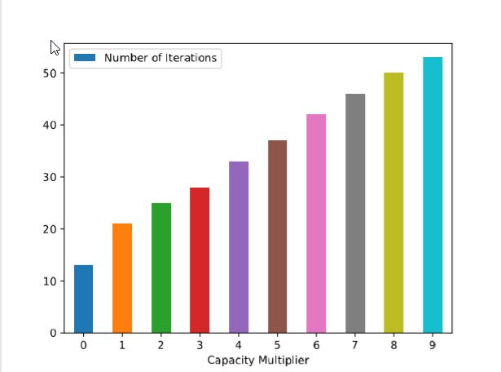The results of the simulation show an almost linear trend between the number of iterations, and the capacity multiplier.

In addition, using the [StatsModels Python API](https://www.statsmodels.org/stable/index.html) linear regression was performed on the DataFrame generated by the simulation, the results are listed here.

OLS Regression Results

===============================================================================

Dep. Variable: capacity_multiplier R-squared: 0.993

Model: OLS Adj. R-squared: 0.992

Method: Least Squares F-statistic: 1148.

Date: Tue, 28 Aug 2018 Prob (F-statistic): 6.29e-10

Time: 17:23:28 Log-Likelihood: 0.12676

No. Observations: 10 AIC: 3.746

Df Residuals: 8 BIC: 4.352

Df Model: 1

Covariance Type: nonrobust

========================================================================================

coef std err t P>|t| [0.025 0.975]

----------------------------------------------------------------------------------------

Intercept -3.4864 0.250 -13.925 0.000 -4.064 -2.909

number_of_iterations 0.2295 0.007 33.885 0.000 0.214 0.245

==============================================================================

Omnibus: 2.226 Durbin-Watson: 1.688

Prob(Omnibus): 0.329 Jarque-Bera (JB): 0.982

Skew: 0.762 Prob(JB): 0.612

Kurtosis: 2.817 Cond. No. 110.

==============================================================================

Next, the Capacity Multiplier was fixed to 0.2, and the Reward Interval was fixed to [150-250], and the experimental variable was the Cost Per Cell.

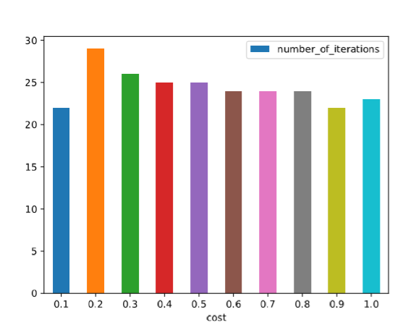

The same linear regression API was applied to the dataframe resulting in the following data

OLS Regression Results

==============================================================================

Dep. Variable: cost R-squared: 0.230

Model: OLS Adj. R-squared: 0.134

Method: Least Squares F-statistic: 2.391

Date: Tue, 28 Aug 2018 Prob (F-statistic): 0.161

Time: 17:38:11 Log-Likelihood: -0.40704

No. Observations: 10 AIC: 4.814

Df Residuals: 8 BIC: 5.419

Df Model: 1

Covariance Type: nonrobust

========================================================================================

coef std err t P>|t| [0.025 0.975]

----------------------------------------------------------------------------------------

Intercept 2.2656 1.113 2.036 0.076 -0.301 4.832

number_of_iterations -0.0703 0.045 -1.546 0.161 -0.175 0.035

==============================================================================

Omnibus: 7.013 Durbin-Watson: 0.670

Prob(Omnibus): 0.030 Jarque-Bera (JB): 2.594

Skew: -1.116 Prob(JB): 0.273

Kurtosis: 4.116 Cond. No. 306.

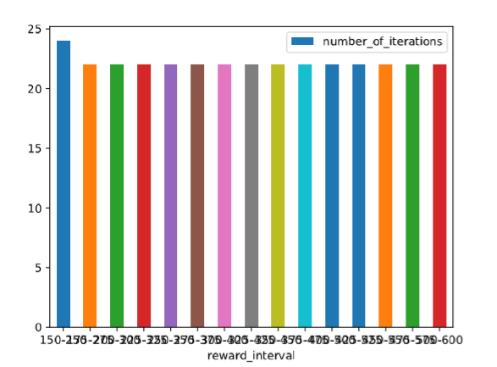Fixing Cost Per Cell to 0.2, and Capacity Multiplier to 5 we get the following results.